This recurrence relation has a time complexity approximately like this:

$T\left(n\right)=3T\left(n-1\right)+O(1)$,where n denotes the length of the road.

It is 3T(n-1) because we need to find the remaining road’s minimum path, and we need to do this for each of the traffic lane. There are 3 lanes to calculate and remaining roads minimum path will be given as T(n-1). The min function takes O(n) time to find the minimum in the given list. Since we usually taking the minimum of the 3 elements, instead of writing O(n) we can directly write O(3) or O(1). The base case will be T(1) = 0.

To solve this recurrence relation, we can use the recursion trees. The tree will start with T(n) and it will divide into 3 parts which are T(n-1). At each recursive call the branches will divide into 3 parts. As shown.

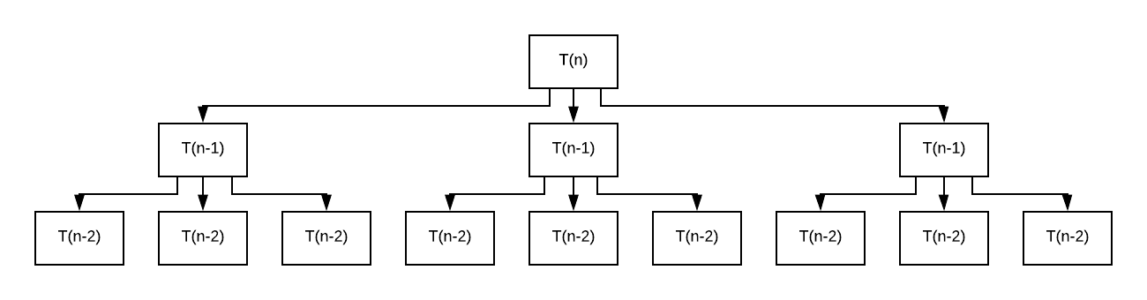

**.**

**.**

**.**

In the end we will have 3n leaves and the height will be n. So, the solution to the recurrence will be 3n which means the time complexity will be O(3n).

Space complexity will also be O(3n) since for each recursive call we create a variable named sum. All in all, we will have O(3n) recursive calls (# leaves in our recursion tree) so the space complexity will also be O(3n).